……………………………………………………………………………………………………….
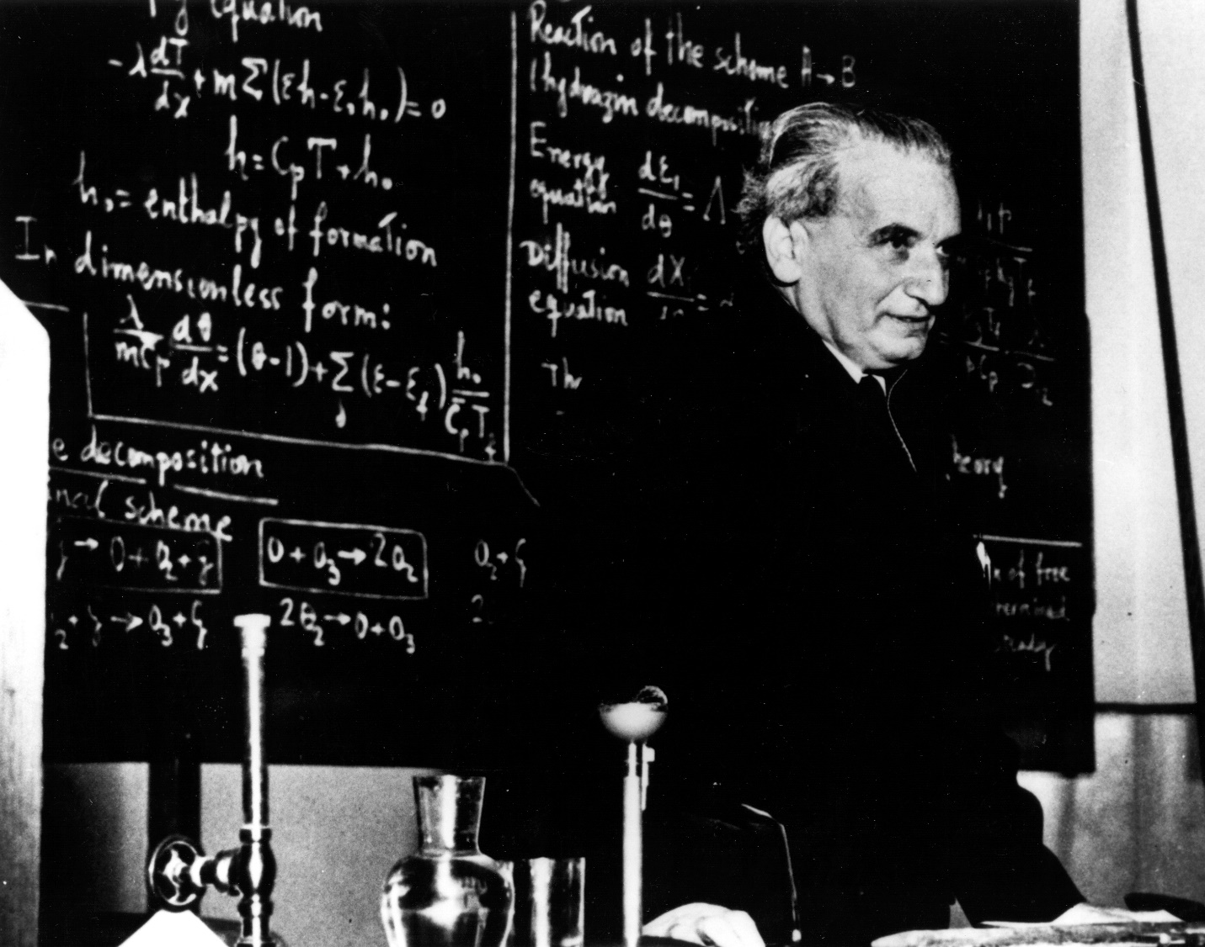
Theodore von Kármán
Theodore von Kármán, after whom the “Kármán vortex street” computed in many of these simulations is named, is regarded as one of the greatest aerodynamicists and mechanicians of the twentieth century.
Born May 11, 1881 in Budapest, Hungary, von Kármán displayed exceptional mathematical abilities at a young age. He attended a model secondary school for gifted children, started by his father, called the “Minta Gymnasium” where (later) one of the other pupils was Edward Teller, popularly known as the “father of the hydrogen bomb.”
After graduating from Budapest’s technical university with a degree in mechanical engineering in 1902, von Kármán moved to the University of Gottingen, in Germany. After receiving his doctorate in 1908, he taught there for four years.
After a brief appointment at a provincial mining academy in what is now Slovakia, in 1913, von Kármán received an appointment at the technical university of Aachen, in Germany, where he remained until 1930, except for a period of service in the Austro-Hungarian army during World War I, and in the Hungarian Ministry of Education during the short-lived postwar communist government. In 1930, in part due to apprehension about the worsening political climate in Europe, von Kármán left Aachen to accept the directorship of the Guggenheim Aeronautical Laboratory at the California Institute of Technology, where he had been spending roughly half of his time for several years.
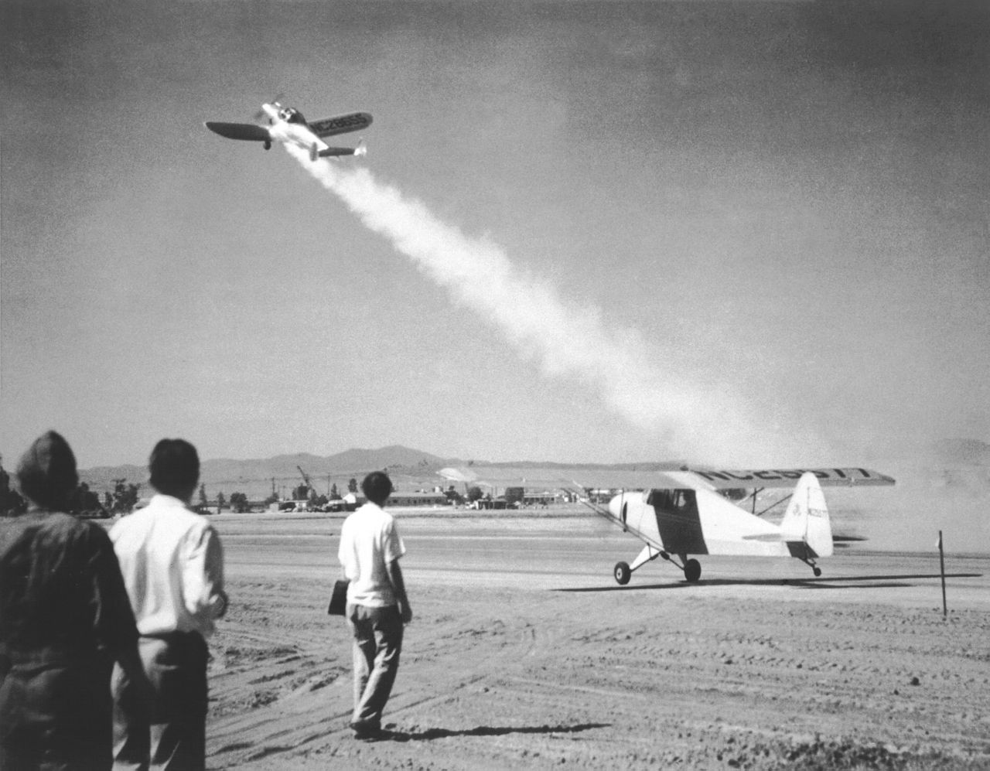
Jet Assisted Take Off
He and a former graduate student (Frank Malina) demonstrated the first long-burning solid rocket propellant. During World War II, von Kármán was instrumental in the development of JATO, or Jet Assisted Take Off, which allowed aircraft to take off from shorter runways with the assistance of attached expendable rockets, a leading producer of which was a company (Aerojet Engineering Corporation; now known as Aerojet Rocketdyne) founded in March 1942 by von Kármán, Malina, and several close associates. In November 1943, von Kármán became the founding Director of the Jet Propulsion Laboratory (JPL), a government-owned, Caltech-operated laboratory responsible for most of NASA's planetary exploration missions.



After World War II, von Kármán worked on a number of important advances in aeronautics and aerospace engineering. One of the most important was the swept-back wing; von Kármán was instrumental in recognizing its importance for both faster and more efficient flight. The swept-back wing is found on virtually all jet aircraft.
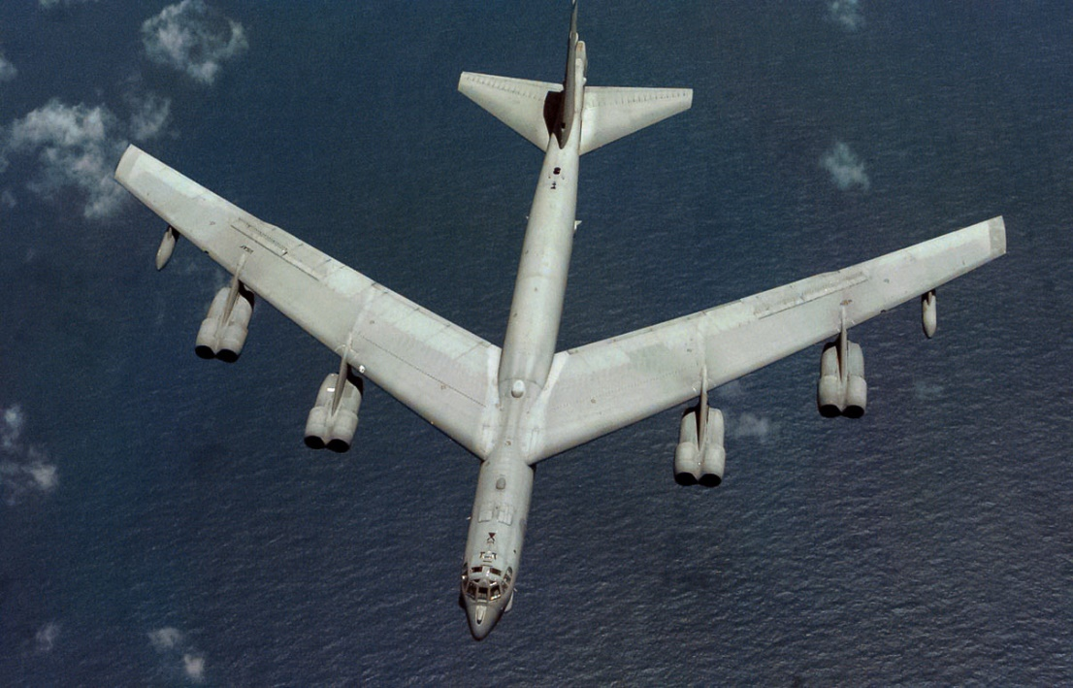
The Swept-Back Wing of a B-52
After officially retiring from his Caltech positions in 1949, von Kármán became a much sought after consultant to a number of industrial concerns and government agencies. He was the first recipient of the National Medal of Science in 1963 from President John F. Kennedy, with the citation reading:
“For his leadership in the science and engineering basic to aeronautics; for his effective teaching and related contributions in many fields of mechanics, for his distinguished counsel to the Armed Services, and for his promoting international cooperation in science and engineering.”
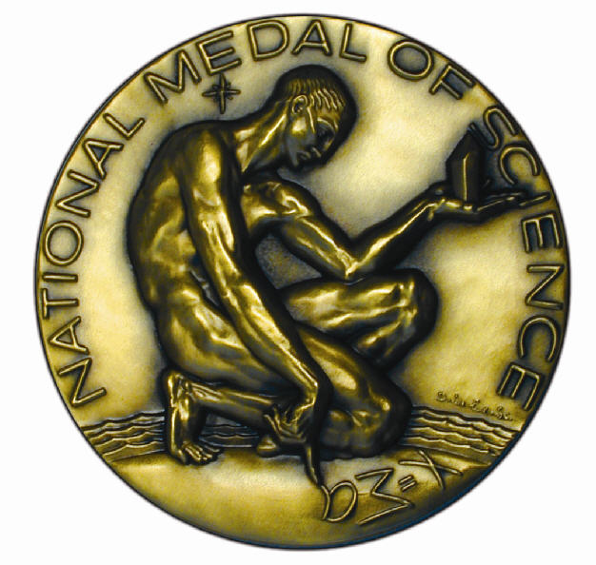
The National Medal of Science
Von Kármán never married, and lived with his sister Josephine until his death. The de Karman graduate student fellowships at Caltech were endowed by him in honor of his sister, and are called the “de Karman” fellowships and not the “von Kármán” fellowships because after coming to the United States, Josephine legally changed her name to de Karman. Von Kármán died May 6, 1963 at the age of 81 while on a visit to Aachen, Germany.
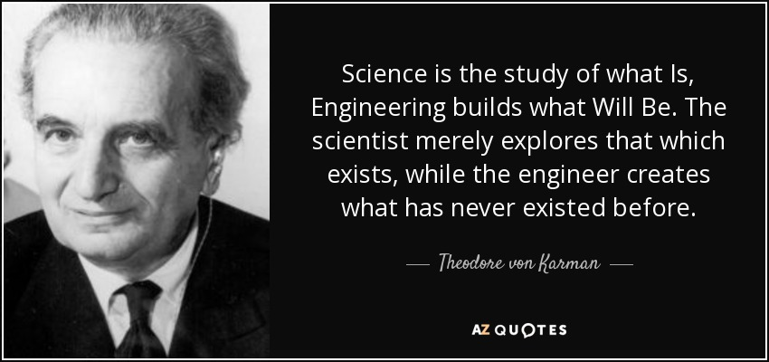

For more on Theodore von Kármán:
https://en.wikipedia.org/wiki/Theodore_von_K%C3%A1rm%C3%A1n

http://www.britannica.com/biography/Theodore-von-Karman

https://www.aip.org/history/acap/biographies/bio.jsp?vonkarmant

http://www.jpl.nasa.gov/jplhistory/learnmore/lm-vonkarman.php

……………………………………………………………………………………………………….

